**PROCESO DIRECCIÓN DE FORMACIÓN PROFESIONAL INTEGRAL**

**FORMATO GUÍA DE APRENDIZAJE**

**IDENTIFICACIÓN DE LA GUIA DE APRENDIZAJE**

**Formación titulada virtual contingencia COVID 19**

* Denominación del Programa de Formación:
* Código del Programa de Formación:
* Nombre del Proyecto ( si es formación Titulada **)**
* Fase del Proyecto ( si es formación Titulada)
* Actividad de Proyecto:
* Competencia: **INTERACTUAR EN LENGUA INGLESA DE FORMA ORAL Y ESCRITA DENTRO DE CONTEXTOS SOCIALES Y LABORALES SEGÚN LOS CRITERIOS ESTABLECIDOS POR EL MARCO COMÚN EUROPEO DE REFERENCIA PARA LAS LENGUAS. 240202501**
* Resultado de Aprendizaje Alcanzar: **03 DISCUTIR SOBRE POSIBLES SOLUCIONES A PROBLEMAS DENTRO DE UN RANGO VARIADO DE CONTEXTOS SOCIALES Y LABORALES.**
* Duración de la Guía: 48 HORAS
* Formación: Virtual.
* Herramientas de trabajo: PLATAFORMA TERRITORIUM, WHATSAPP, VIDEO CONFERENCIAS ZOOM, MEET.
* Recepción de evidencias: Vía WhatsApp, Email, Territorium.

**2. PRESENTACIÓN**

**5 Types of Work Environments**

Your work environment is made up of all of the elements that can affect your day-to-day productivity, including when, where and how you work. During your career development, you can pursue opportunities that provide a comfortable work environment that promotes your success and aligns with your core values. Let’s discuss what work environment is, the elements that make it up and how to best identify a suitable work environment during your job search.

There are many different types of work environments that include a combination of physical components, company culture and working conditions. What elements make for the best type of work environments depend on an organization’s industry and age, the number of and types of employees, and the ideal environment the organization wants to cultivate.

According to the Holland theory of personality and job compatibility, some environments may be a better match for certain personalities. When considering a work environment, discover the characteristics and values of your personality type to find one that best suits you.

**3. FORMULACIÓN DE LAS ACTIVIDADES DE APRENDIZAJE**

**3.1 WORKSHOP VOCABULARY QIZLET**

What is a work environment?

A work environment is the setting, social features, and physical conditions in which you perform your job. These elements can impact feelings of wellbeing, workplace relationships, collaboration, efficiency, and employee health. Here are the significant aspects of a work environment:

**Physical environment**: This element is made up of the size, layout, and location of a workplace, whether work is conducted indoors or outdoors, the facilities offered in a workplace and the furnishings used while working.

**Company culture**: This element refers to the way a company and its employees operate, including what effective communication looks like between different levels of staff, employees’ perspective of company leaders, the company’s goals and what the organization values.

**Working conditions:** This element includes the formal terms under which staff members are hired, such as the rate of pay, contract of employment and length of the workday. It can also cover recreational activities and other initiatives to promote a healthy workplace.

**Physical environment**: The physical conditions you work under will play a crucial role in enabling you to reach your full potential. Some critical aspects of your physical environment to consider include:

**Size**: The size of your working area can have an impact on whether you have everything at hand to accomplish your job, while at the same time significantly influencing how you feel at work. To evaluate the size of your workspace, consider the amount of space you must move freely, whether you have all the equipment you need nearby and if the area is large enough to accommodate all staff members.

**Layout**: Some indoor workplaces have an open floorplan, while others use cubicles or other dividers to separate spaces. The design of a workplace may depend on the type of work. For example, a more collaborative environment may benefit from an open layout, while a job that requires discretion would better operate with separate offices or cubicles to ensure privacy.

**Furnishings**: Desks, chairs, conference tables and other workplace furniture can also impact employees on the job. Access to comfortable and adequate seating, clean workspaces and functional desks can ensure indoor workplaces remain efficient. Outdoor workplaces may include comfortable furniture for break times.

**Equipmen**t: Some roles require special equipment to do their job, and depending on the company, the employer may or may not provide it. Some roles, such as a mechanic, may be required to bring their own set of tools. Indoor office spaces are more likely to provide the necessary equipment, such as computers, printers and other essential technology used on the job.

**Facilities**: Other facilities can influence how you feel physically and mentally during your working life. Being able to take a break or go to the bathroom are essential parts of any productive daily routine, so the location of these facilities can also impact the work environment. Additional facilities such as relaxing spaces and on-site gyms can also have a positive influence on employees.

**Location:** Some roles predominantly work inside; some spend most of their working day outside and certain roles may have a mixture of both indoor and outdoor work. Many employers may provide additional facilities or equipment to ensure employees are comfortable while working and productivity is maintained.

**Check your workplace conditions, tools, materials, location, equipment, machines, layout sizes etc.; and design a Quizlet flashcard using the vocabulary related to those features. If you consider it is necessary to write the meaning and pronunciation of the word, you can add these to the flashcards.**

**First, watch the Quizlet tutorial video** [**https://www.youtube.com/watch?v=Ih34upKBj0A**](https://www.youtube.com/watch?v=Ih34upKBj0A) **and then continue with your design.**

**Link to Quizlet webpage:** [**https://quizlet.com/es**](https://quizlet.com/es)

**Develop WORKSHOP VOCABULARY ACTIVITY and don’t forget to submit this through your Territorium LMS platform.**

To develop this activity, you must pay attention to your class explanation through **ZOOM, WHATSAPP VIDEO TUTORIALS OR MEET**. Download the Word file, fill it out and resend it through the **Territorium LMS platform, WhatsApp, or E-mail.**

Don’t forget to follow the tutor instructions.

* Place required: workshop, classroom, library,
* Materials: market, pen, video beam, learning guide, tv.

**3.2 WHERE IS IT?**

**First, check your knowledge:** [**https://learningapps.org/506484**](https://learningapps.org/506484)

**PREPOSITIONS OF PLACE AND MOVEMENT**

**Prepositions of place**

We use prepositions of place to say where things are**.**

|  |  |  |
| --- | --- | --- |
| **Preposition of place** | **Explanation** | **Example** |
| **in** | * inside | * I watch TV **in** the living-room * I live **in** New York * Look at the picture **in** the book * She looks at herself **in** the mirror. * She is**in** the car. * Look at the girl **in** the picture * This is the best team **in** the world |
| **at** | * used to show an exact position or particular place * table * events * place where you are to do something typical (watch a film, study, work) | * I met her **at** the entrance, **at** the bus stop * She sat **at** the table * **at** a concert, **at** the party * **at** the movies, **at** university, **at** work |
| **on** | * attached * next to or along the side of (river) * used to show that something is in a position above something else and touching it. * left, right * a floor in a house * used for showing some methods of traveling * television, radio | * Look at the picture **on** the wall * Cambridge is **on** the River Cam. * The book is **on** the desk * A smile **on** his face * The shop is **on** the left * My apartment is**on** the first floor * I love traveling **on** trains /**on** the bus / **on** a plane * My favorite program **on** TV, **on** the radio |
| **by, next to, beside, near** | * not far away in distance | * The girl who is **by**/**next to** /**beside** the house. |
| **between** | * in or into the space which separates two places, people or objects | * The town lies halfway **between** Rome and Florence. |
| **behind** | * at the back (of) | * I hung my coat **behind** the door. |
| **in front of** | * further forward than someone or something else | * She started talking to the man **in front of**her |
| **under** | * lower than (or covered by) something else | * the cat is **under** the chair. |
| **below** | * lower than something else. | * the plane is just **below** the the cloud |
| **over** | * above or higher than something else, sometimes so that one thing covers the other. * more than. * across from one side to the other. * overcoming an obstacle | * She held the umbrella **over** both of us. * Most of the carpets are **over** $100. * I walked **over** the bridge * She jumped **over** the gate |
| **above** | * higher than something else, but not directly over it | * a path **above** the lake |
| **across** | * from one side to the other of something with clear limits / getting to the other side | * She walked **across** the field/road. * He sailed **across** the Atlantic |
| **through** | * from one end or side of something to the other | * They walked slowly **through** the woods. |
| **to** | * in the direction of * bed | * We went **to** Prague last year. * I go **to** bed at ten. |
| **into** | * towards the inside or middle of something and about to be contained, surrounded or enclosed by it | * Shall we go **into** the garden? |
| **towards** | * in the direction of, or closer to someone or something | * She stood up and walked **towards** him. |
| **onto** | * used to show movement into or on a particular place | * I slipped as I stepped **onto** the platform. |
| **from** | * used to show the place where someone or something starts: | * What time does the flight **from** Amsterdam arrive? |

**Prepositions of movement:**

Prepositions of movement show movement from one place to another place. These prepositions always describe movement and we usually use them with verbs of motion.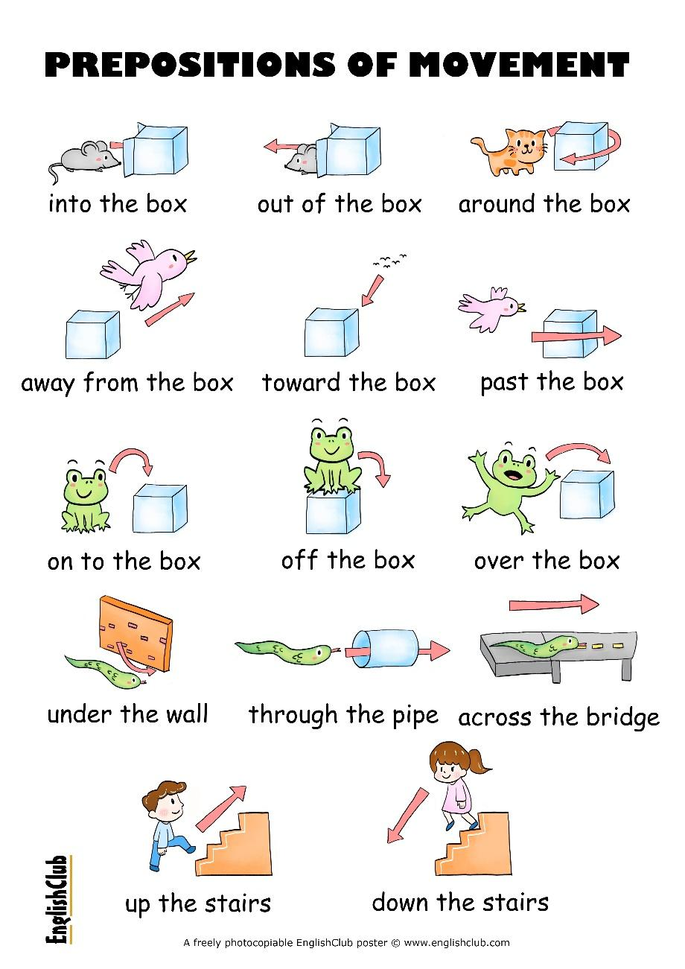

The most common preposition of movement is the preposition to, which describes movement in the direction of something, for example:

* How do you go to work?
* He drove to London in five hours.
* Nobody came to the party :(

**Prepositions of Movement list**

Here is a list of the most common prepositions of movement, with example sentences for each one:

across: movement from one side to the other side of something

* It took us three days to drive across the desert.
* The dog ran across the road and nearly got hit by a car.

around: movement passing something in a curved route, not going through it

* A big dog was sleeping on the floor so she had to walk around it.
* They walked around the town for an hour.

away from: indicating the point where a movement begins:

* The mouse ran away from the cat and escaped.

down: movement from a higher point to a lower point of something

* They ran down the hill to the stream below.
* He climbed down the ladder to the bottom of the well.

from: indicating the point where a movement begins

* We flew from Bangkok to London.
* The police took my driving licence from me.

into: movement to an enclosed space; movement resulting in physical contact

* He got into the car and closed the door.
* The car crashed into the wall.

off: movement away from (and often down from) something

* Please take your papers off my desk.
* The wineglass fell off the table and shattered on the floor.

on to, onto: movement to the top surface of something

* They went up on to the stage.
* Move the kettle onto the counter.

out of: indicating the enclosed space where a movement begins

* Take your hands out of your pockets and help me!
* He went out of the room to smoke a cigarette.

over: movement above and across the top or top surface of something

* We are flying over the mountains.
* The cat jumped over the wall.

past: movement from one side to the other side of something

* We could see children in the playground as we drove past the school.
* We gave the marathoners water as they ran past us.

to: movement in the direction of something

* Could you give this to Kob please?
* Does this train go to London?

through | thru (AmE): movement in one side and out of the other side of something

* The train goes through a tunnel under the hill.
* Hey! You just went thru a red light!

towards | toward (mostly AmE): movement in the direction of something

* The night sky got brighter as they drove toward the city.
* At last she could recognize the person coming towards her.

under: movement directly below something

* The mouse ran under the chair.
* Submarines can travel under water.

up: movement from a lower point to a higher point of something

* Jack and Jill ran up the hill.
* The boat takes two hours going up the river and one hour coming down.

**Develop WHERE IS IT? WORKSHEET. Don’t forget to submit the activity through your LMS platform.**

**3.3 DESCRIBING THE WORKPLACE**

Check first the vocabulary about adjectives to describe places, practice with this activity:

<https://wordwall.net/es/resource/3272585>

**Words that Embrace a Place**

The words we choose will allow the reader to understand the writer's perspective. To call something bustling and vibrant is quite different from desolate and deserted. Will any of these descriptive words for places stoke the flames of your next scene?

* Alive - Full of life
* Attractive - Pleasing; charming
* Beautiful - Having qualities that are pleasing or appealing
* Bustling - Full of life, energy
* Calm - Peaceful; free from stress
* Charming - Fascinating; likeable
* Cosmopolitan - Appealing to people from all across the globe
* Enchanting - Delightful; fascinating
* Fascinating - Alluring; captivating
* Fresh - Something newly made and full of vigor
* Homey - Cozy; inviting
* Inspiring - Enlivening; motivating
* Lively - Full of life and spirit
* Peaceful - Calm; friendly
* Picturesque - Scenic; beautiful
* Unspoiled - Untouched by man; pure
* Vibrant - Full of life; energy

**Words to Express Dislike for a Place**

If the show doesn't fit, don't force it. Go ahead and call it polluted, rundown, or even horrifying. Try to evoke scents as well as sights with your prose. Some of these words may be subject to opinion, such as crowded or touristy, but readers will quickly catch your connotation.

* Bleak - Gloomy; somber
* Boring - Dull; uninteresting
* Creepy - Causing feelings of fear or disgust
* Crowded - Filled to capacity
* Deserted - Abandoned; uninhabited
* Desolate - Empty; bleak
* Dull - Boring; lacking zest
* Expensive - Costly; having a very high price
* Horrifying - Frightening; disgusting
* Nightmarish - Resembling a bad dream
* Polluted - Dirty; contaminated
* Rundown - In poor condition
* Stormy - Turbulent; tempestuous
* Touristy - Of or for tourists, suggesting tastelessness
* Ugly - Visually unpleasing

**More Words to Describe a Place**

Sometimes, it all boils down to the facts of the matter. Perhaps you're visiting ancient ruins or staying at a contemporary resort. Here are some unbiased descriptors to help you label a place:

* Ancient - Belonging to an earlier period of time
* Contemporary - Existing in the present time
* Magical - Captivating; enchanting
* Majestic - Grand; impressive; stately
* Modern - Of or relating to the current time.
* Mystical - Magical; enigmatic
* Quiet - Not noisy
* Traditional - In keeping with conventional customs.

**Develop DESCRIBING THE WORKPLACE activity. Don’t forget to submit the activity through your LMS platform.**

To develop this activity, you must pay attention to your class explanation through ZOOM, MEET or Video tutorials in WhatsApp. Download the Word file, fill it out and resend it through the **Territorium LMS platform, WhatsApp, or E-mail.**

Don’t forget to follow the tutor instructions.

**3.4 GIVING INSTRUCTIONS AT WORKPLACE**

**7 Positive Communication Practices**

* Always provide context for the task to be completed. People do their best work when they understand the importance of the task to the larger operation. When you take the time to explain the business importance of the task you are requesting to be completed, you are teaching and showing respect for the individual you asked to complete the work.
* Be specific when assigning tasks. Outline when the task must be completed and share any quality standards.
* Ask the team member to complete the tasks. Choose a respectful tone of voice, polite words and deliver the message with the appropriate volume. Contrast these statements: "Go unload that truck," and "John, the shipment on that truck is needed on the production line. Please help unload the truck before noon." There is little doubt the latter approach would be perceived as positive and the former as negative.
* Give your team a chance to ask questions. Offer the individual(s) being asked to complete the task the opportunity to clarify their questions. This step helps strengthen communication between the employee and supervisor and improves the probability of a successful outcome. The employee has the opportunity to confirm that he or she truly understands what is being asked of them.
* Trust your employees. Resist the urge to oversee or micro-manage an employee's completion of the requested task. Part of leading effectively is learning to trust that your team can complete tasks without you.
* Reinforce your employee's confidence. Offer appropriate thanks and positive feedback for jobs completed properly.
* Ensure you give constructive feedback. Offer clear, behavioral, focused feedback for any tasks that are completed improperly.

**Develop GIVING INSTRUCTIONS AT WORKPLACE activity. Don’t forget to submit the activity through your LMS platform.**

To develop this activity, you must pay attention to your class explanation through ZOOM, MEET or Video tutorials in WhatsApp. Download the Word file, fill it out and resend it through the **Territorium LMS platform, Whatsapp, or E-mail.**

Don’t forget to follow the tutor instructions.

**3.5 DESCRIBING MY WORKPLACE**

**Create a presentation and a video record about *Describing your Workplace*. This video must have the vocabulary used and explained in the previous activities (prepositions of place and movement, place description adjectives, workplace description vocabulary). Don’t forget to submit the activity through your LMS platform.**

To develop this activity, you must pay attention to your class explanation through ZOOM, MEET or Video tutorials in WhatsApp. Download the Word file, fill it out and resend it through the **Territorium LMS platform.**

Don’t forget to follow the tutor instructions.

**4. ACTIVIDADES DE EVALUACIÓN**

All the activities before will be taking into account to be evaluated.

|  |  |  |
| --- | --- | --- |
| **Evidencias de Aprendizaje** | **Criterios de Evaluación** | **Técnicas e Instrumentos de Evaluación** |
| **Evidencias de Conocimiento :**   * Where is it? * Giving instructions at workplace   **Evidencias de Desempeño:**   * Video with oral report about your workplace description * Describing the workplace   **Evidencias de Producto:**   * Workplace Quizlet Vocabulary | - Interpreta un texto sencillo y puede construir un mapa conceptual basado en el mismo.  - Pronuncia adecuadamente el vocabulario y modismos básicos del idioma  - Sostiene conversaciones con vocabulario básico y técnico aprendido.  - Elabora resúmenes cortos sobre textos sencillos, y con contenido técnico.  - Escribe o presenta descripciones de sí mismo, su profesión y su entorno.  - Plantea y responde preguntas sobre sí mismo. - Realiza vídeos o audios interactivos relacionados con la actividad de aprendizaje que esté desarrollando. | **Questionnaires**  **Role play**  **Workshops**  **Videos**  **Audios**  **Video conferencias.**  **ZOOM, MEET WHATSAPP ATTENDANCE** |

**5. GLOSARIO DE TÉRMINOS**

Support material: Material de apoyo

Slides: Diapositivas

Daily routine: Rutina diaria

Steps: Pasos

Folder: Carpeta

Download: Descargar

Main: Principal

Peer: Compañero

Check: Revisar

**6. REFERENTES BIBLIOGRÁFICOS**

<https://www.englishclub.com/vocabulary/prepositions-movement.htm>

<https://en.islcollective.com/download/english-esl-worksheets/grammar/prepositions/prepositions-place-and-movement-practice/101294>

<https://www.indeed.com/career-advice/finding-a-job/types-of-work-environments>

<https://learnenglish.britishcouncil.org/skills/speaking/pre-intermediate-a2/giving-instructions>

<https://www.linguahouse.com/esl-lesson-plans/>

<https://wordwall.net/es/resource/3272585/adjectives-describe-places>

<https://grammar.yourdictionary.com/grammar/word-lists/list-of-words-to-describe-places.html>

**7. CONTROL DEL DOCUMENTO**

|  |  |  |  |  |
| --- | --- | --- | --- | --- |
|  | **Nombre** | **Cargo** | **Dependencia** | **Fecha** |
| **Autor (es)** | **Lina Marcela Camargo**  **Mayra Mojica** | **Instructora**  **Instructora** | **Bilingüismo**  **Bilinguismo** | **Julio 2021**  **Julio 2021** |

**8. CONTROL DE CAMBIOS** (diligenciar únicamente si realiza ajustes a la guía)

|  |  |  |  |  |  |
| --- | --- | --- | --- | --- | --- |
|  | **Nombre** | **Cargo** | **Dependencia** | **Fecha** | **Razón del Cambio** |
| **Autor (es)** |  |  |  |  |  |